Identification de l’incident :

|  |  |  |  |
| --- | --- | --- | --- |
| **De :** | Agnes MAZAS |  |  |
| **Date** | 21/01/2020 | | |
| **Classification** | •MAM : Manual Audit – New Asset selected | | |
| **Reproductible : Yes** | | | |
| **Version IE** : IE 11.0.9600.18860CO | | | |
| **Version client 3D :** (Connexion au client 3D : touche shift+Ctrl+v) : VDC5.6.4 . MAM.01.19.2020 | | | |

Steps to reproduce :

# Problem

After selecting a New Asset and Validate it, it does not appear at “Verified – New” status.

# Steps to reproduce

## Create manual AUDIT

* On Staging, create Audit_Recette_1 to audit manually rack V3-F-06.

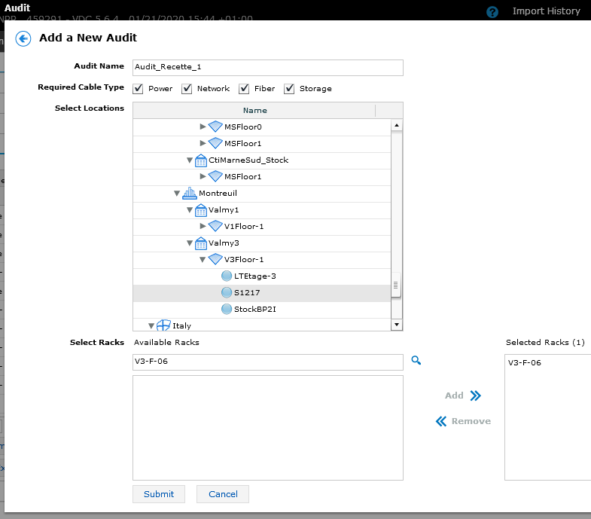

## Add New Asset with New_Asset button

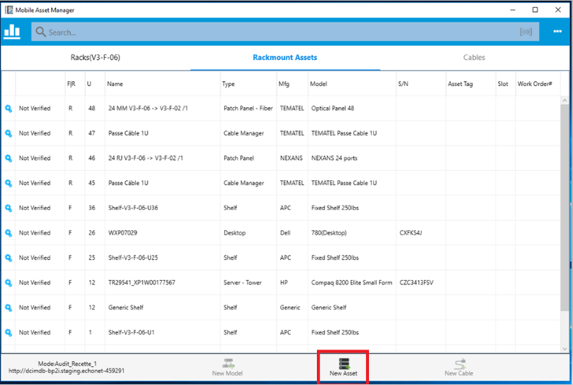

## Select device 0025XHG6 from list, then select Front and Rack U 2.0

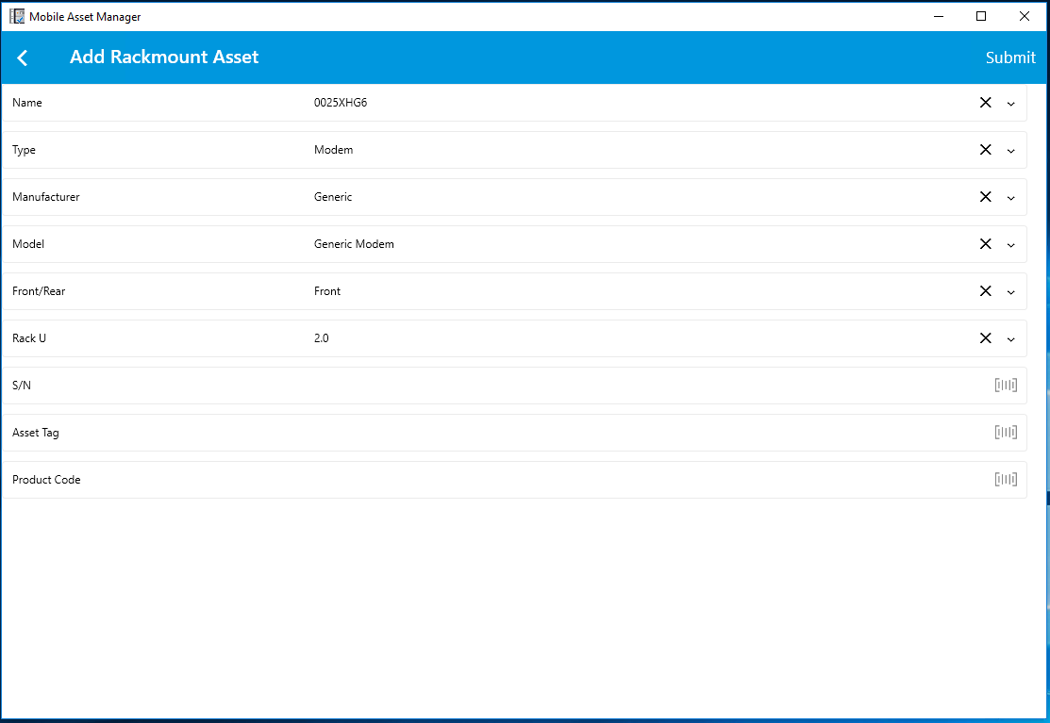

Submit :

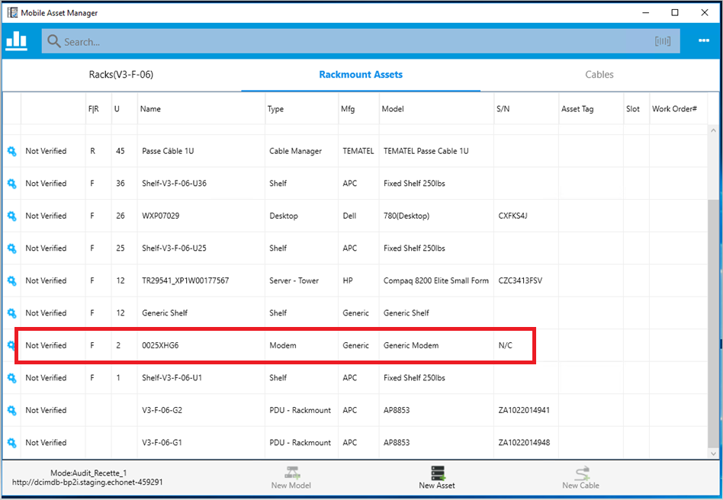

## Validate this device

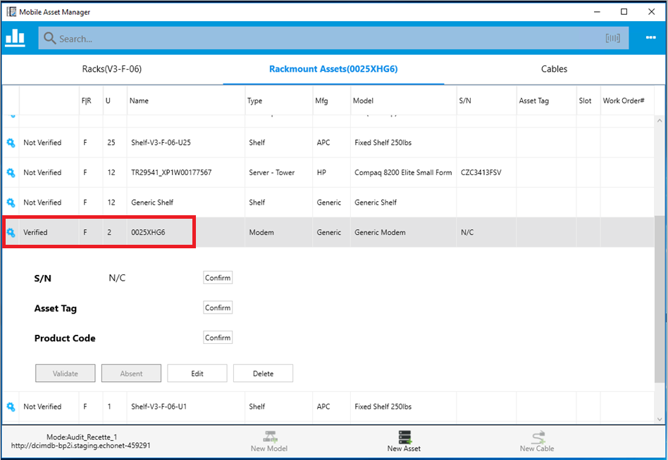

It appears at “Verified” status whereas we expected “Verified-New” status.